DOCUMENTATION MATLAB JOYSTICK
Josep Tormo Costa 30/10/2014

1-Open JoyTest.m with Matlab.
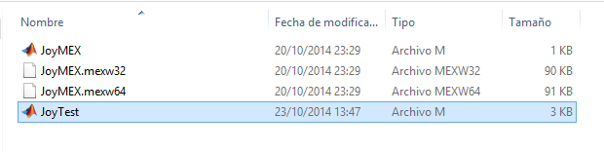
2-Run it.
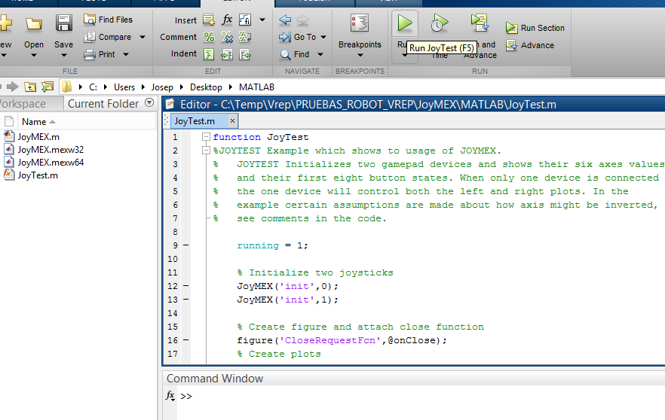

3-And say yes if a prompt require you to change the matlab folder.
